RECRUITMENT MANAGER

© Amblin Software (2007-2010)

Version 1.5

Introduction

The Recruitment Manager is the total solution for facilitating the hiring of personnel to your organization. With Recruitment Manager, you can keep track of the various stages of the hiring process. With intelligent auto-matching keywords and the face-to-face interview, you are able to combine both subjective and objective factors in determining the right person for the job.

Some of the features of the software are given below:

1. Maintain your Applicant and Interviewee Lists easily with Drag-and-Drop lists.
2. Maintain your Job Vacancy details easily including job description, technical and non-technical keyword matching, remuneration details, probation and notice duration, locations, departments etc.
3. Analyze your advertising efficiency by matching applicant source to advertiser and then finding the ratio of dollar spent to advertiser per applicant.
4. Divide the interview process into 4 stages, Applied / 1st Interview / 2nd Interview / Hired. Easily advance interviewees from one stage to the next, recording their skills and printing reports on their technical and non-technical merits as well as observations during the face-to-face interview. Get a percentage fit based on matching keywords and priority weighting.
5. Easily transfer existing employees to the applicant list (internal applicant) and also transferring the hired applicant to the employee database.
6. Use the in-built email generator to send out customized letters to the interviewees at different stages of the recruitment process. It may be a letter of regret for the unsuccessful applicants at Stage 0. Invitees to 1st Interview, Regret unsuccessful applicants at 1st Interview, Congratulations for hired employee etc. You can create your own templates and choose from a pre-defined list of merge fields build the email template.
7. Besides having a standard interview report, you may use the RTF report generator to custom build a questionnaire based on any particular vacancy.
8. Print Visitor ID Cards for interviewees.
9. Filter a list of applicants by inputting search criteria.

Let Recruitment Manager help you make the right decision, each time, every time. Any other way could cost you more than just inconvenience!

If the application is unregistered you are limited to 5 vacancies. After registration there is no limit to the number of jobs.

Print Setup

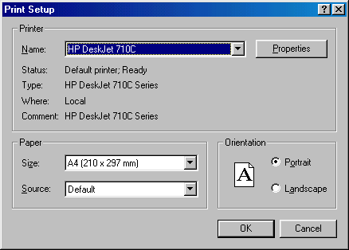

The first thing you would do is set up the printer details if you are printing over a network. Choose a printer that is set for A4 sheet feeder as all the reports in the application are set for this. In addition all reports are previewed before being sent to the printer. Go to Properties if you need to change the number of copies etc. You can choose which pages to print on the File Menu of the print preview. After choosing the page range click on the Print icon.

When printing reports you may want to print a particular page and not the whole report. You can do this by going to File (after printing to screen) and choosing “Pages to print” and then inputting the page range eg, 1-3, 3-3, 5-6 etc. Then click on the printer icon to output those pages only.

All reports can now be out put in 5 different formats as shown below. The report will preview first and then you need to click on the <Print> button to output the report to your preferred destination. The XML encoding is ISO-8859-1 and the format is “Tags”. If you require another format email us at info@amblinsoftware.com

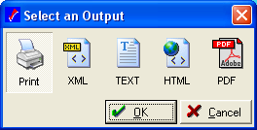

System Setup

This option is accessed through the Setup menu. The system setup includes all the details that are global to the whole organization. It is important to get the details here correct as it flows through out the entire system. Most of the fields are self-explanatory. The first screen sets up the company details. Whatever you put in here will flow through to the Registration form. It is a good idea to enter your details here first before you do anything else.

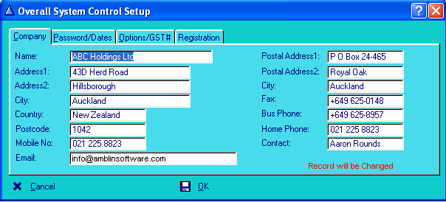

On the second <Tab> you will find the system date and the supervisor password. The first time you use the system to change the password you need to type “roll” as current password and then change the password and verify it by typing it in again. It is a good idea to change it and allow access to the “System Menu” to only the user “SUPER’.

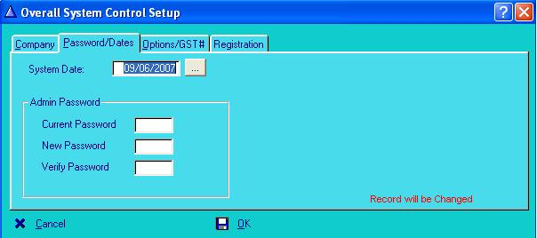

The last <Tab> allows you to enter all registration information so that you may enter information into the modules that you purchase. This screen also contains the registration details. On the Registration form that will be faxed or e-mailed back to you will contain the serial number. Any restrictions will be lifted once the product is registered. Please note that the Serial number is based on the Company name (case sensitive), the number of companies, the number of users and the number of shareholders. A good rule of thumb is to choose number of shareholders as one and a half times what you currently have eg, if you have 50 shareholders, choose 50 x 1.5 = 75, but the next option up is only 100.

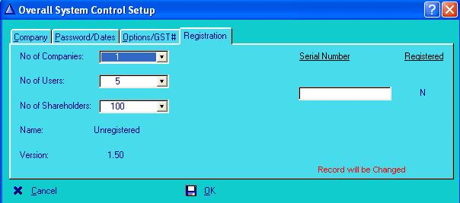

No of Companies Choose number of companies for licensing. Valid choices are 1,10,20,100 and unlimited.
No of Users Choose number of Users. The number of users, number of shareholders and the Company Name is used to generate the Serial Number for registration. Valid choices are 1,5 and 10.
No of Shareholders Choose maximum number of shareholders that are input into system. Valid choices are 20,100, 50 and unlimited.
Serial Number Enter Registration code that is supplied by the Vendor. Print out the registration form in the 'Help Menu' and fill in the details and fax it. You should receive a Serial number within 24 hours if paying by Credit card. Alternatively email to: info@amblinsoftware.com with Company details (Name, Postal Address).
Successful Registration Once you have entered the serial number that you received, the successful registration flag should change to ‘Y’ and you it will no longer be just a demonstration version. You will be restricted to the number of companies, users and shareholders that you chose above.

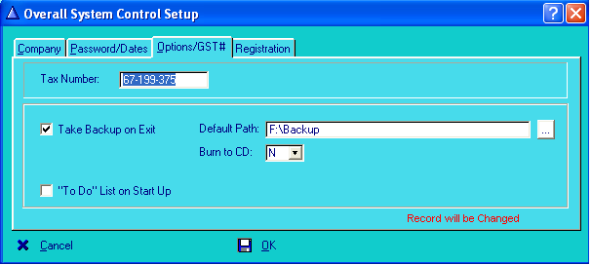

Tax Number Enter the Company Tax number here
Default Path If the default path is entered then the “Burn to CD” option is “N” for No. The backup file is in the format yyyymmdd.zip and can be restored via the “Utilities” menu.
To Do List Tick this if you want the “To Do List” to pop up when you start the application.

Applicant Master file

Most of the fields are self-explanatory and when in doubt you can right click and invoke the context sensitive help to see what that particular field is about. The Demo system only allows 5 applicants. but once it is registered it allows as many applicants as the license you buy eg, 100, 500, 500+ applicant license. You can find an applicant by Name, Post Code. An Inactive member is shown in gray in the ‘Inactive’ <Tab>. Double clicking the highlighted record takes you into the record for that applicant. You can add a new applicant by right clicking and choosing <Insert> or just hitting the <Insert> key on your keyboard.

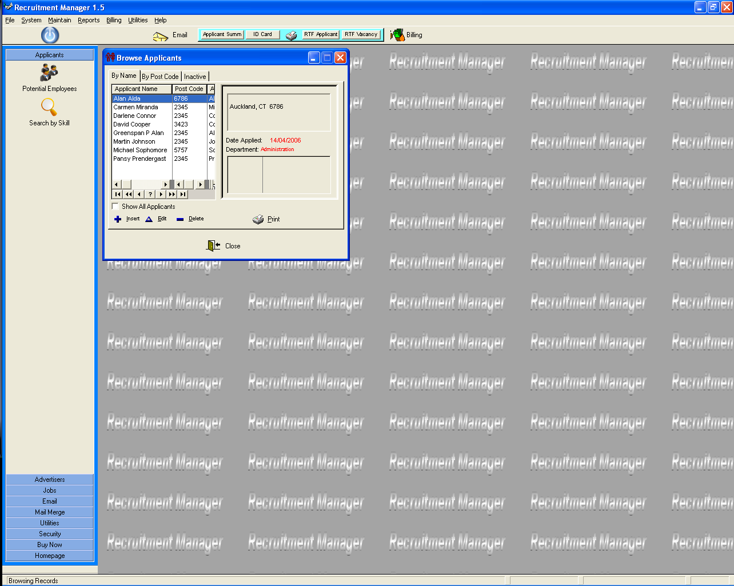

In the update form (above right), enter the relevant information. If some of the options are not available eg, a new employee type or department. Go and add it under the “Browse Menu”.

Click on to insert a new record.
Click on to change an existing record
Click on to delete an existing record

Control What it Does
Show all applicants Tick this check box to shows all applicants, both active and inactive (the inactive applicants are shown in gray).
*Internal Applicant Choose and create an applicant from the Employee database. You will be warned if an applicant with the same name already exists.
*Create an Employee Choose and create an employee from the applicant database. You will be warned if an employee with the same name already exists.
Note: Right click and <Help?> will explain a particular field in the ‘Update Applicant Record’ window .

* Only applicable if integrated to HR Control Centre.
Applicant Master File – Personal Details

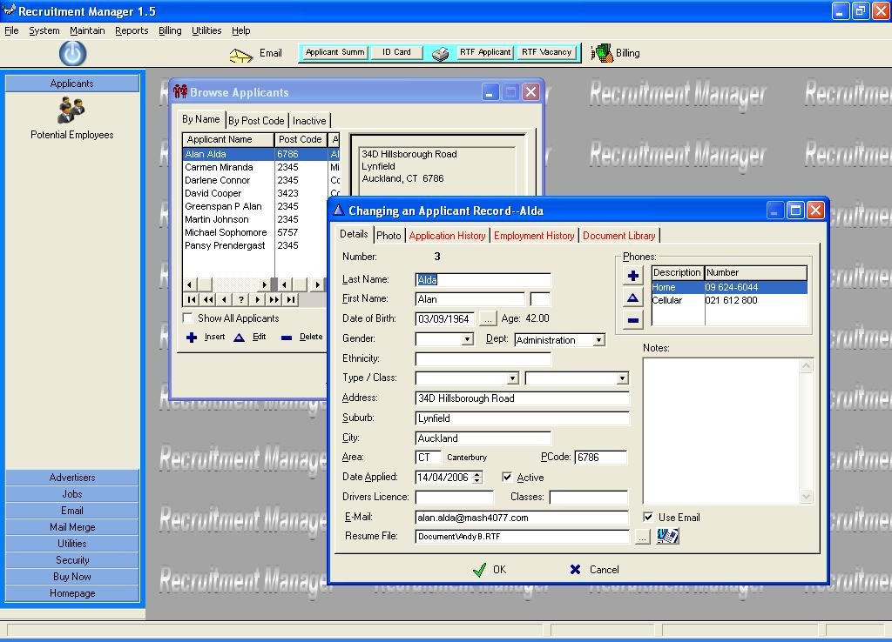

Control Description

Last Name: Enter First name of applicant.
First Name: Enter Last name and Initial of applicant.
Date of Birth: Enter (or lookup) applicants date of birth. Age displayed on the right.
Gender: Choose the applicants gender.
Department: Enter department where vacancy exists.
Ethnicity: Enter the ethnic group the applicant belongs to.
Type/Class: Enter applicant type and classification.
Address: Enter applicants street or mailing address.
Suburb: Enter applicants suburb or postal area.
City: Enter city where applicant is resident.
Area: Enter Location code where applicant resides.
Post Code: Enter postal code where applicant resides.
Date Applied: Enter first contact date for this applicant or first date of receiving correspondence from this applicant.
Active: Check if applicant is active ie, currently applying for a vacancy.
Drivers License: Enter drivers license number.
Classes: Enter driving classifications here.
Email Address: Enter applicants email address. This may be used for corresponding with the applicant.
Email Flag: The 'Use Email' checkbox must be ticked for emails to be sent out.
Resume File: Enter the path to the CV for this applicant. It may be easier to use the lookup on the right to locate the document. Clicking on the button on the far right will open the document for perusal. Document File Formats supported are *.doc, *.rtf and *.pdf
Phones: Enter all the phone contacts for this applicant.
Notes: Enter free form text regarding this applicant.
Photo: Link to a graphic picture file of the applicant
Applicant Master File – Skill Set

Enter the skills that the applicant has in the order of decreasing strength. Attribute 1 will contain the primary skill and Attribute 10 will contain a supplementary skill that may help filter a search for a particular job skill set. The search key is a concatenation of all the individual skills.

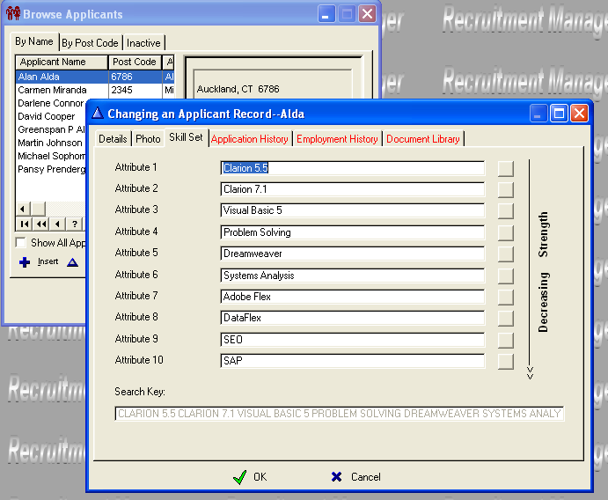

In the “Search by Skill” function you may enter a string of search keywords and get a % fit.

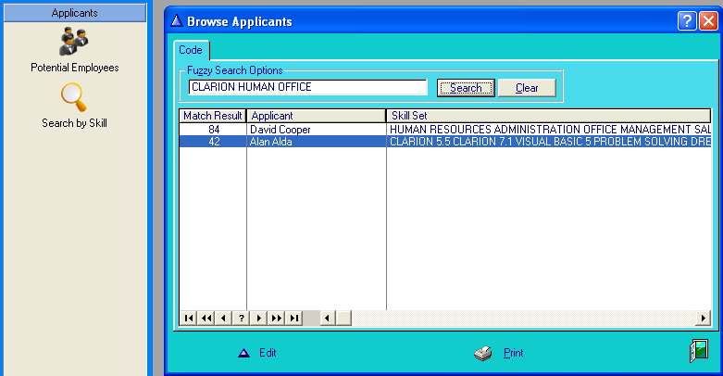
Applicant Master File - Application History

This window lets you know at a glance how many times the applicant has applied for a job in this company and what stage he/she reached in the interview process (‘0’ meaning not considered for an interview, ‘1’ meaning first interview, ‘2’ meaning second interview and ‘3’ meaning the applicant was hired). Click on the <View> button to look at details of the application consideration for the highlighted job.

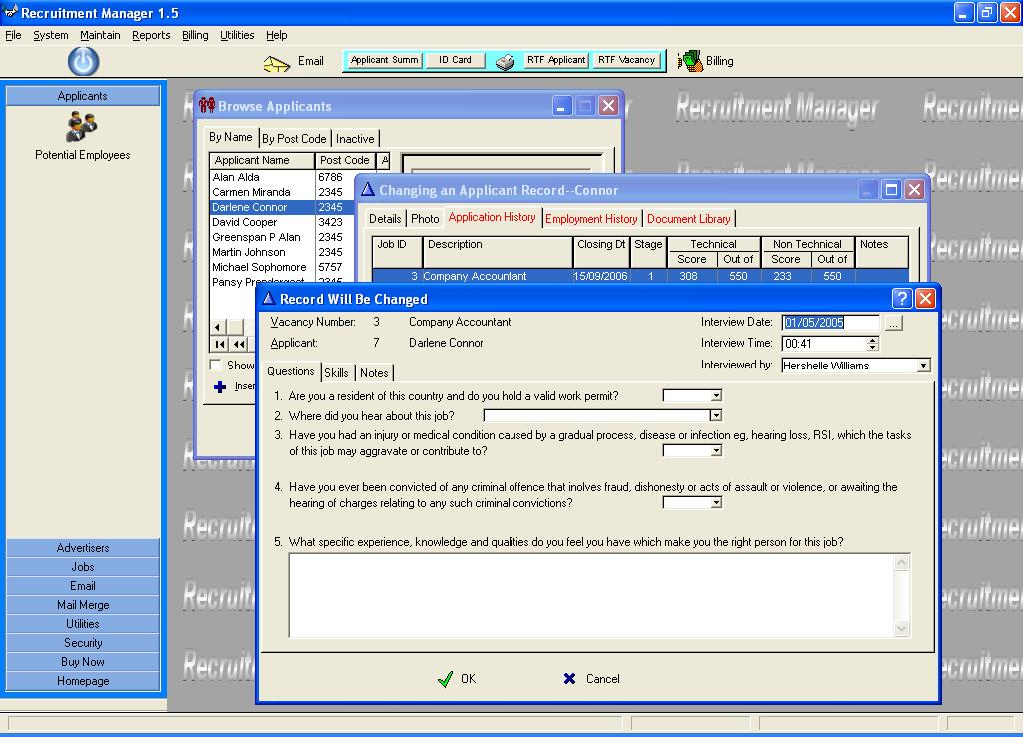

It can save the interviewer a lot of time by just going through past interviews, particularly to see the reasons why the applicant was unsuccessful previously. It can also be counter productive in forming a bias before going through the application in an objective manner. Something to consider is how old these records are to be relevant. If it is a few years old then it may or may not be fully applicable, in which case the HR Manager should use their discretion in selecting an applicant for an interview.

Applicant Master File - Employment History

It is useful to record past employment history for an applicant to see trends in their employment progress. It may be immediately obvious if say for example an employee has a high job turnover in a small period of time demonstrating instability.

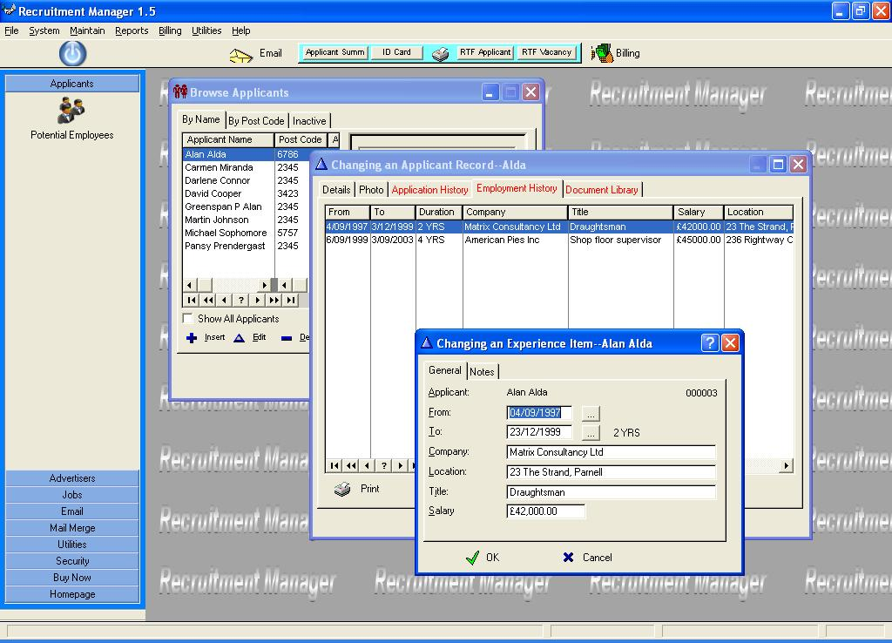

Control Description

Applicant: Applicants Name and ID.
From Date: Enter Date when the applicant commenced work at that company..
To Date: Enter Date when the applicant stopped working at that company..
Company: Enter the name of the company that the applicant worked for in the above defined period.
Location: Enter area where company premises were located.
Title: What was the highest position reached by this Applicant.
Salary: What was the last salary drawn by the applicant at this company.
Notes: Enter any relevant notes pertaining to this applicants tenure at this company. For example, reason for leaving, any achievement of note whilst at this company etc.

Applicant Master File – Document Library

The document library is a useful resource in storing and viewing documents that the applicant has supplied. You may attach as many documents to the library as you wish.

The file types supported are:
*.doc and *.rtf => MS Word
*.pdf => Acrobat Reader
*.gif, *.jpg and *.bmp => MS Paint

This means that as well as Word and Acrobat, you can store scanned images as well. Scanned images are opened in MS Paint (Note: Older versions of MS Paint do not support .jpg or .gif files, only .bmp).

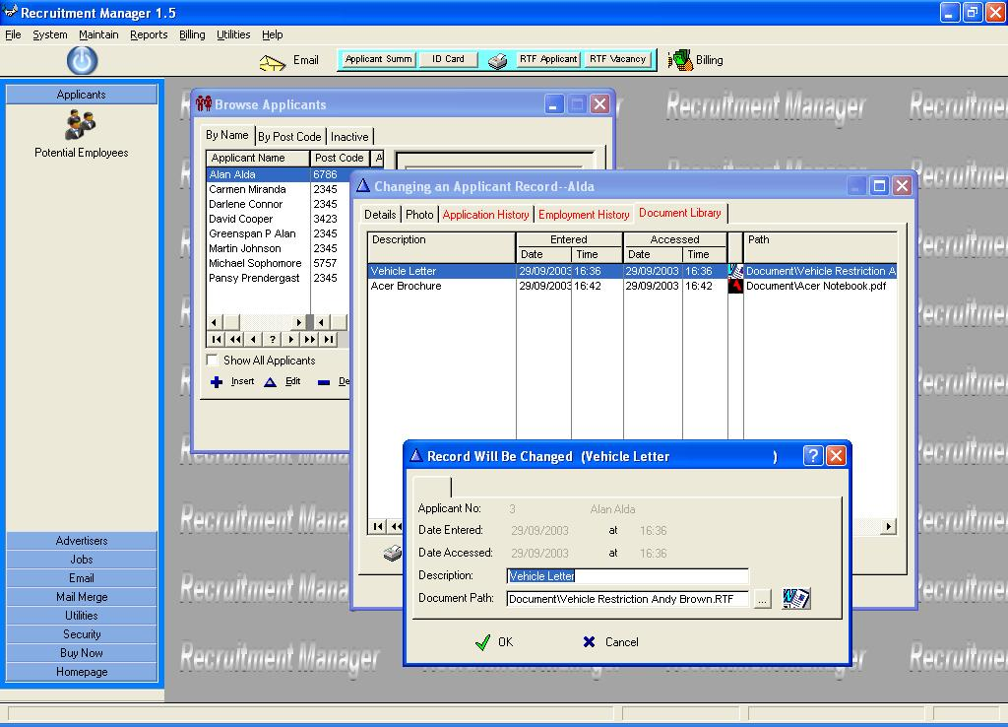

Control Description

Applicant: Applicants Name and ID.
Date Entered: Date document was attached to the library is recorded.
Time Entered: Time document was attached to the library is recorded.
Date Accessed: Date document was last accessed is recorded.
Time Accessed: Date document was last accessed is recorded.
Description: A meaningful description of the document eg, Diploma in Business
Document Path: Enter (or lookup) the path to the document. Remember you do not need the full path name for it to work. You can truncate it to a relative path from the directory where personel.exe resides. For example: “C:\Program Files\Amblin Software\HRM Multi\Document\Vehicle Restriction Andy Brown.RTF” can become “Document\Vehicle Restriction Andy Brown.RTF”
Graphical Button: Click on this to open the document with the correct Application.

Advertiser Master file Setup

This browse shows all the advertising and recruitment agencies that you have commissioned for the purposes of filling this vacancy.
From this window you can add or remove or modify the information for an advertiser.
You can navigate through the list using standard keys or through the toolbar. The panel on the right displays additional information (address and phone contacts) about the highlighted entry in the list.

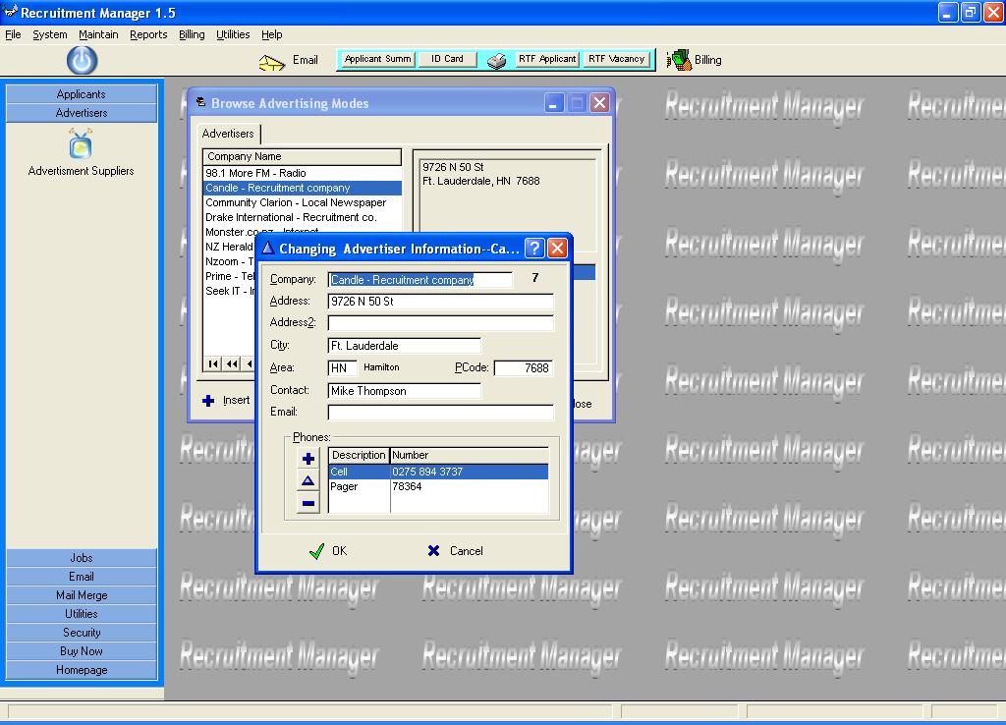

To add an Advertiser: Press insert or on the toolbar.
To modify the highlighted Advertiser record: Press enter or on the toolbar.
To delete the highlighted Advertiser record: Press delete or on the toolbar.

Add the phone contact details for the advertiser by inserting (+), changing (Δ) or deleting (-) a record.

Note: Right click and <Help?> will explain a particular field in the ‘Update Advertiser Information’ window .

Maintain RTF Letters

This utility lets you create custom MS Word compatible letters to merge and send by either email or print a hard copy.

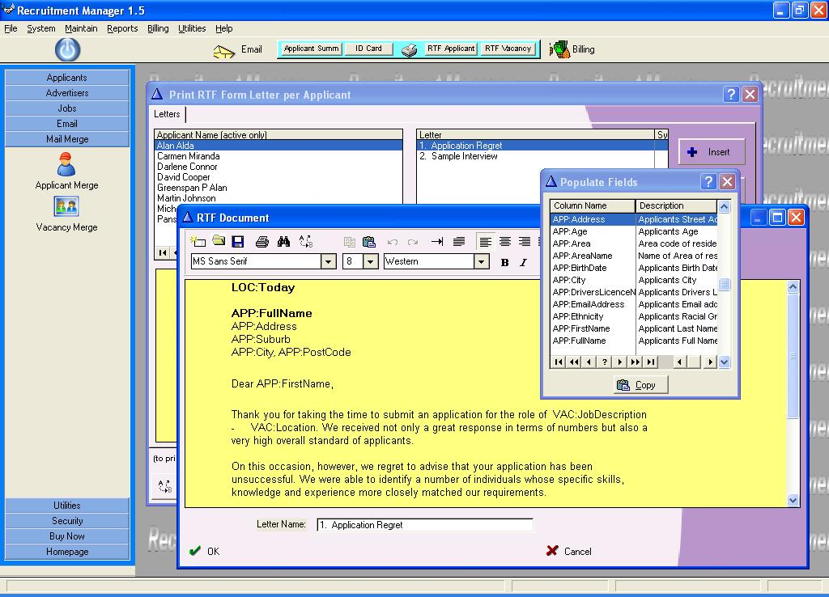

You may choose merge fields to paste onto your custom letter. These fields are from the ‘Applicant’, ‘Company’, and ‘Vacancy’ databases.

Browse Areas

Add Area codes, descriptions and postcodes that are relevant to your company.
Double click on an existing area record or press <Insert> to add a new area code. The
Area code is used to validate the area the employee belongs to.
Area Code: Put a meaningful code in here to reflect the name.
Area Name: Full Name of Area
Post Code: This is the Postal code for that area.

Area codes are used in the Member, Sponsor and Vendor master files.
This window displays a list of areas, highlight the area you want to use and press the Select button (or DOUBLE-CLICK on the area).

Browse Departments

This is used to enter a department description which is used later in the Member master file.
Use the drop list in the Update member screen to choose a department. It is mandatory to have a department. If it does not apply, create a department called ‘Not Applicable’ and choose that option from the drop list.

Browse Letters

A simple yet effective letter template. It consists of only 2 fields; the letter “Type” and the letter “Body”. The letter type is a meaningful name given to the letter. Type in the text that forms the body of the letter. To print the letter go to “Reports / Vacancy Reports / Print Letters/Invites” option and choose the vacancy and the letter and press <Go>.

Browse Vacancies

Clicking on the wrench icon brings up the browse Vacancies window and drilling down to the update form brings up the window below. There are 4 tabs when updating a vacancy; these are :
1. The main screen with Job Description, remuneration details and notes, and
2. The skill keywords which matches applicants to the job, and
3. The third tab where you add interviewees and allocate tables for seating, and
4. The line items where you add the costs of advertising itemized by agency.

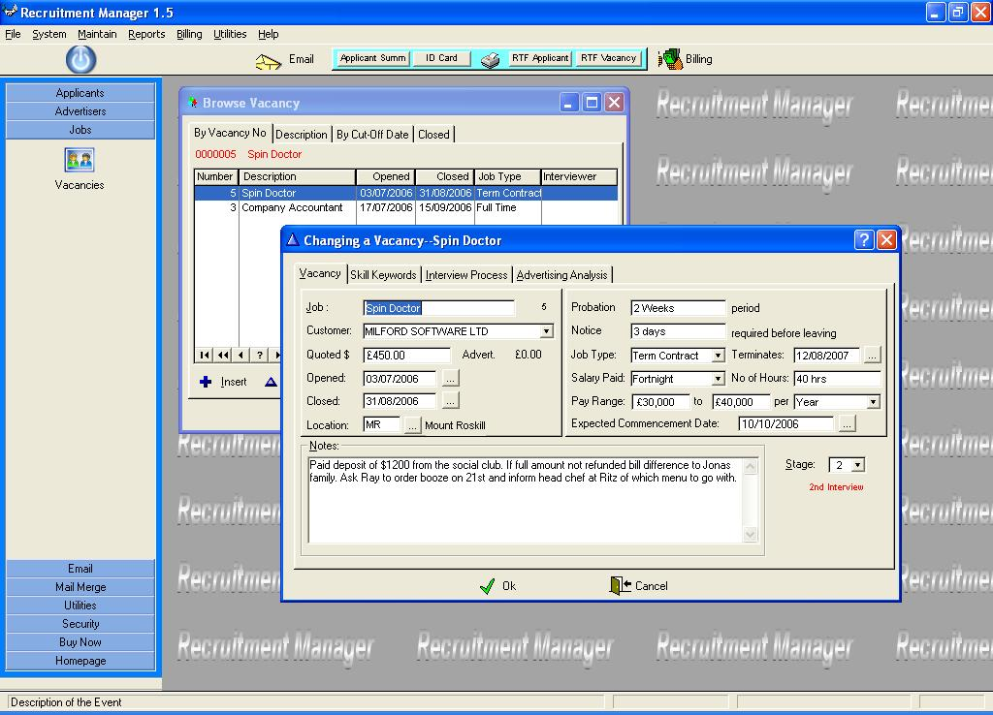

Control Description

Job: Add a description of the vacancy. This is usually a title eg, ‘Systems Analyst’.
Reports To: Choose the department head under whom the new employee will serve.
Department: Which department will the new employee be allocated to.
Opened: When did we first advertise this job?
Closed: When do we stop accepting applications and start processing them?
Location: What is the area or physical location of premises where new employee is to be deployed.
Probation: For what amount of time is the new employee on probation before position is confirmed.
Notice: For what amount of time is the employee allowed to give notice before leaving the job. This will also be reflected in the Employment Contract.
Job Type: Enter a job type. You can maintain job types under 'Browse Job Type'.
Terminates: If it is a contract job, it will usually have a conclusion date so enter it here. It can of course be extended or reduced by mutual consent.
Salary Paid: How often are wages paid to the employee. This could be directly into a designated bank account, handed over personally or some other way.
No of Hours: Enter the number of hours worked within the pay period. You may qualify this by adding 'per wk' etc if it differs from the pay period.
Pay Range: Enter the lower and upper range of remuneration offered for this position.
Per: The remuneration period for the above stated salaries.
Notes: Enter any notes pertaining to this Vacancy.
Stage: This shows the progression of the job interview process. It can be manually changed or automatically by moving the interviewees through their stages. For example if you have allocated an applicant to the first interview stage, it will automatically reflect that on this screen. Similarly if you have hired a person, then it will automatically move this vacancy to the 'Closed' stage.

Browse Vacancies – Skill Keywords

The second <tab> is used to enter the skills matrix for the job so that an empirical formula can be worked out. This is based on a descending priority.
For example a skill or attribute that is ranked 1 is more important than 10. An ideal score is then worked out for the job. Each skill/attribute can have 5 scales (Expert/Exact, Good/Almost, Adequate/Moderate, Novice/Poor, None). We give a weighting to each scale 10, 7, 4, 1, 0. In an ideal score we would have (10x10 + 9x10 + 8x10 + 7x10 + 6x10 + 5x10 +4x10 + 3x10 + 2x10 + 1x10) = 550. We then compare the applicants score based on their assessment of how their skills compare with respect to the overall jobs’ skill and scale.

It also depends how many keywords you set up. For example if you only list 5 skills, the maximum score will be (10x10 + 9x10 + 8x10 + 7x10 + 6x10) = 400, so your maximum score is 400.

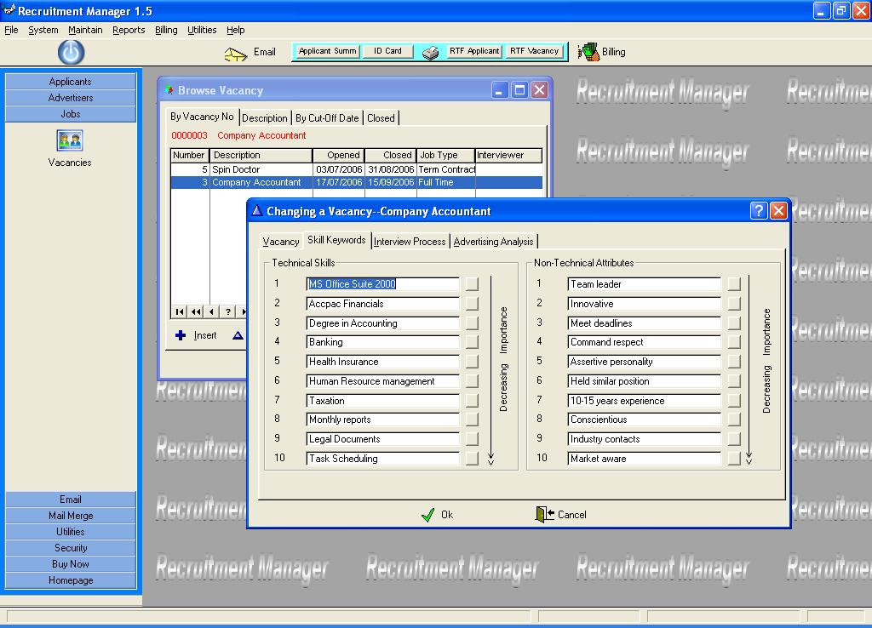

The skills/attributes specific to this vacancy is then available for the individual skills matrix for each applicant for this job.

Browse Vacancies – Advertising Line Items

The fourth tab (line items) browse shows all the agencies which have used to advertise for this job. This list shows all the different media that have carried advertisements relating to this vacancy. All the costs and budgets are recorded. It can also include information on payments to recruitment agencies.

By asking the applicant where they saw the ad for the job you can actually quantify the success or failure of your marketing campaign to the various media organizations.

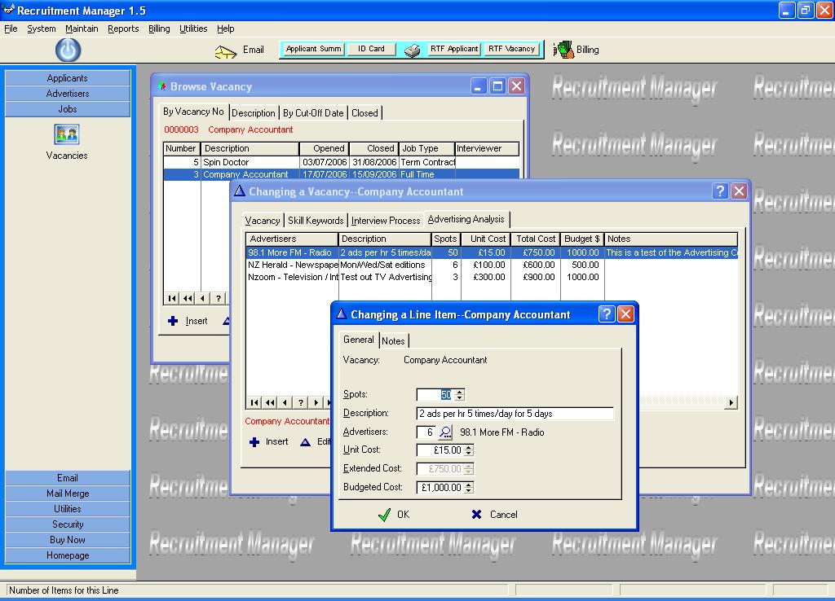

Control What it Does

Spots: The number of advertising slots paid for.
Description: Description of the advertisements. It may show frequency or some other detail of the advertisement.
Advertisers: Enter advertisers vendor number or choose from the lookup. You may add a new advertiser through the ‘Browse / Browse Advertiser’ menu option.
Unit Cost: What is the unit cost for per spot for this mode of advertising.
Extended Cost: This is equal to the Unit Cost multiplied by the number of spots.
Budgeted Cost: The amount budgeted for this form of advertising.
Notes Tab: Notes or special instructions about the item.

Browse Vacancies – Interview Process

The third <tab> is used to control the interview process. You may add the applicants to the Interview list by double clicking or dragging and dropping after invoking the “Add Applicant” option. If the applicant already exists on the interview list, then you will be informed that you cannot add that applicant to the Interview list again. You can also remove interviewees from the list by highlighting and clicking on the “Remove Applicant” option. Clicking on the second icon brings up a floating applicant toolbox from which you can choose an applicant to interview by double clicking or dragging and dropping. Clicking on it again or clicking on the ‘x’ in the top right corner of the floating toolbox will close it.

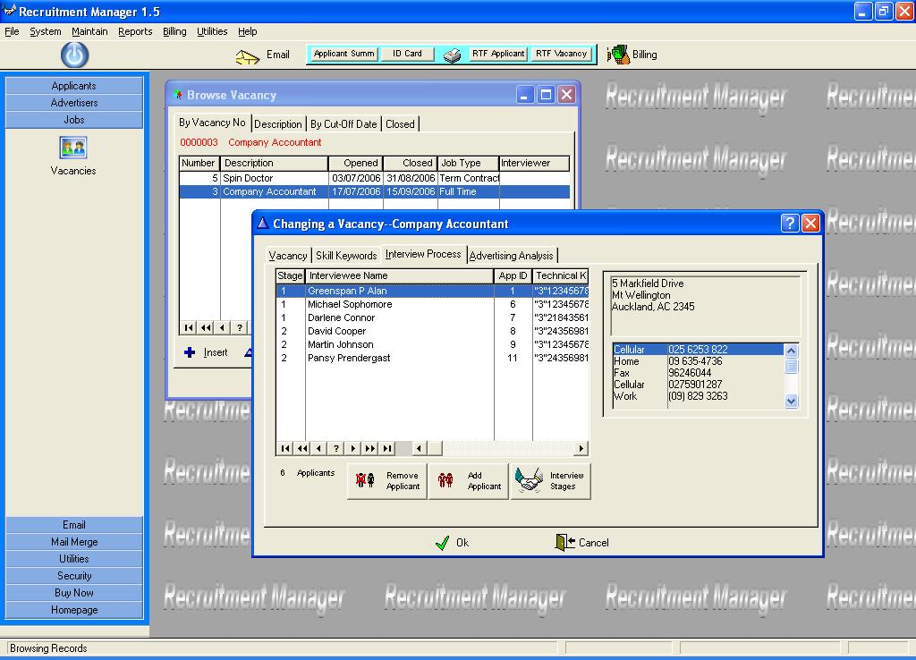

In the browse the first column shows the stages that each applicant has reached in the interview process. On the right is address and phone details of the highlighted applicant.

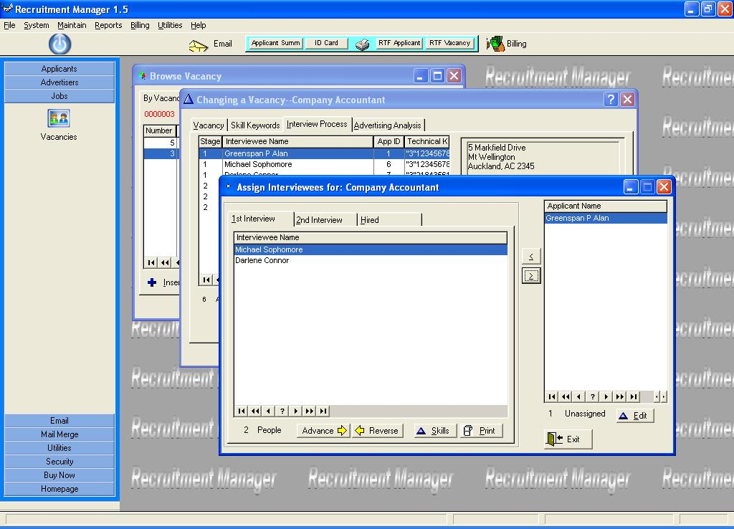

Initially all the interviewees will be in the right hand pane. Clicking on the arrows in the middle of the two panes will move interviewees between them. You may enter details of the interviewees by clicking on the <Edit> or <Skills> buttons. Clicking on the <Advance> button will move the interviewee up a stage eg, from 1st interview to 2nd Interview. Clicking on the <Reverse> button will move the interviewee down a stage eg, from 2nd interview to 1st Interview. Clicking on the <Print> button will print a report of everything you have entered using the <Skills> or <Edit> options as well as the job details.

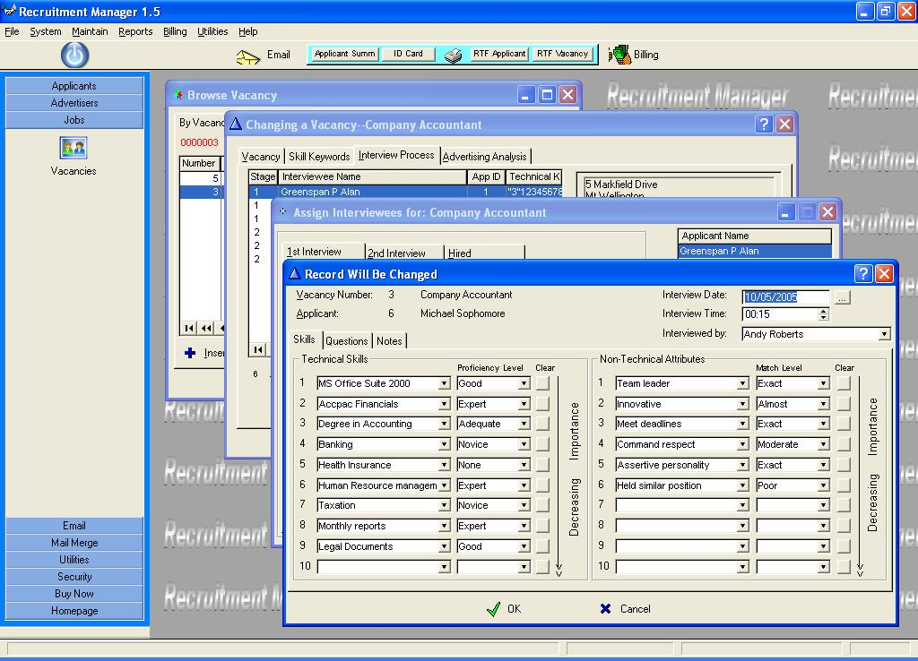

In the <Skills> tab you enter the relative strengths of this applicant with regards to the criteria defined earlier. Once it is entered and saved the system will calculate a technical and non-technical score which can then be compared to a theoretical maximum. It is a good idea to print the Job Summary and use that (because the job description and skills matrix is on it) during the interview process, along with any custom defined (RTF) interview form.

The <Questions> tab contains some standard questions like residency status, media source, medical condition and criminal convictions. Answers to these questions may preclude the applicant from further progress and ultimately save time. Any further questions can be prepared using the custom report generator (Browse / Browse RTF Letter).

The <Notes> tab contains referee information and notes. At this point a conclusion should be formed whether the applicant advances or not.

Email Custom Letters

This is a particularly useful utility for emailing correspondence to the applicants. The letter is defined in the “Browse / Browse RTF Letters” .

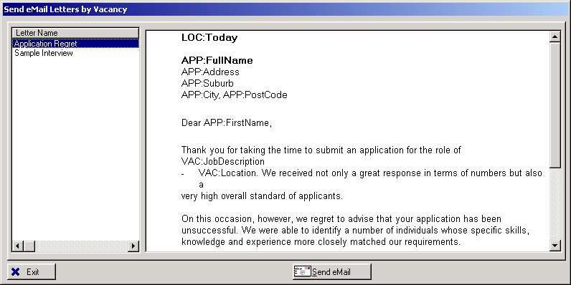

When you click on the <Send email> button, it will ask you whether you are connected to the internet. If you answered ‘Yes’ then the following selection window will appear.

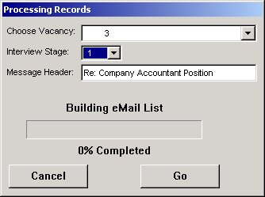

You are to choose the vacancy, interview stage and relevant message header and then press <Go>. The applicant must have a valid email address and the ‘Use Email’ flag must be ticked.

Reports Menu * All reports and labels are A4 size.
Print Job Summary Prints a summary report for a single job, highlighted from the browse window. Shows the job description, skills matrix and a list of all advertisers, costs and exposure ratio.
Print Name Badges Prints Name Badges for a range of applicants and vacancies. This is useful for issuing ID Cards to visiting interviewees.
Print Letters Prints pre-defined letters (“Browse Letters”) for a single vacancy. A list appears allowing you to select the vacancy and pre-defined letter.
Print Advertiser List Prints a list of Advertisers and phone numbers.
Print Advertiser Labels Prints Mailing labels for all advertisers.
Print Applicant List Prints a list of Applicants and phone numbers.
Print Applicant Labels Prints Mailing labels for all Applicants.
Print Applicant Summary Prints a list of Applicants for a particular vacancy and their comparative skills scores.
Print RTF Form Prints a custom report with merge fields by choosing Applicant and Letter.
Print RTF Vacancy Prints a custom report with merge fields by choosing Vacancy, Interviewee and Letter.
Restore Data Files

Be extremely careful with this option as all data files will be overwritten once completed. Ensure that no other users are in the Share application. The default restore directory is the one that is set up in “Overall System Control”. Click on the lookup ellipsis and choose the date of the zip file that you would like to restore. Once chosen the “Ok” button will be enabled and clicking on “Ok” will start the restore process on confirmation. Once restored you will need to restart the Recruitment application and continue with processing.

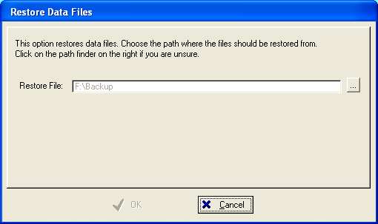
6.0 Billing

The Billing function is used to process an Accounts Receivable system including:

- Customers
- Items – Stock and Non-stock
- Customer Quotes
- Customer Invoicing
- Customer Credit Notes
- Customer Journals
- Customer Receipting
- Reports include: Aged Trial Balance, Statements, Transaction list, Product Sales analysis, Customer purchase analysis.
- You may add Customers, Customer groups, Products and Product groups on the fly while processing invoices.
- Billing supports custom tax processing.
- Perform a period end to roll over and age transactions.
- Use the “Create Invoice” function to transfer a job to an invoice for billing. You can then edit this invoice if you wish by clicking on the "Billing" icon.

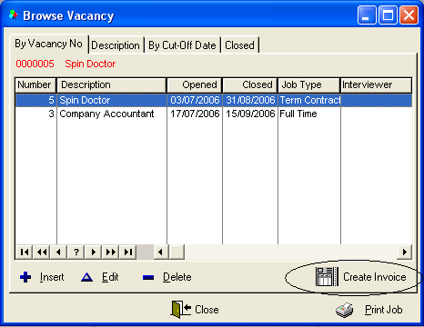

As always to invoke context sensitive help, just right-click on any field and press <Help?>, an explanation is available instantly.

7.0 Technical Notes

Minimum hardware requirements for the Application to run well is a Pentium 75 with 32MB RAM.
Since the application is 32-bit you need Windows XP and above.

